SUBJECT : COMPILER DESIGN
SUBJECT CODE : RCS-602
Assignment - I
Q1 What is Cross compiler ?
Q2) What is boot strapping ?
Q3) What is the difference between single phase and multi pass compiler ?
Q4) What do you mean by leftmost and rightmost derivation ?
Q5) Find the numbers of tokens in the following program:
Main()
{
int x,y,z;
Z=x+y;
}
Q 6) How DFA is minimized? Discuss different steps of constructing FA for regular expression.
Q 7) Convert the following Automata into Regular Expression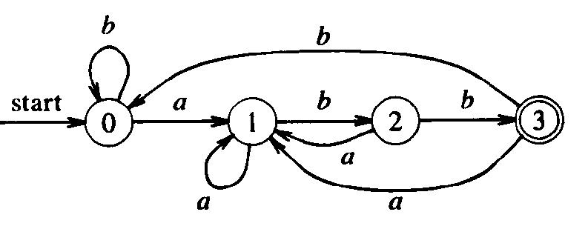
Q 8) Describe the basic structure of compiler.
Q 9) (a) What are some advantages of high level languages over assembly languages ?
(b) What are the major stages in the process of compilation ?
Q 10) (a) Mention few cousins of compiler.
(b) What are the possible error recovery actions in lexical analyzer?
Q 11 (a) Elaborate in detail the recognition of tokens.
(b)What are the issues in Lexical analyzer phase.
Q 12) (a) Write a transition diagram to recognize the identifier.
(b) Write the concept of input buffering in a lexical analysis.
Q 13) (a)What do you understand by ambiguity in grammar?
(b) Define parse tree and give an example of parse tree.
Q 14) What do you understand by lexical –analyzer generator and LEX-compiler.
Q 15) Write short note on the following :
(a) BNF Notation
(b) CONTEXT free grammar
(c) Parse tree

